**Title:** Comprehensive Analysis of the Indian Premier League and Projecting the Optimal Squad for the 2025 Season

**Name:** Niranjan Gopalan

**Email id:** niranjangopalan948@gmail.com

Table of Contents

**Context and Motivation:** 3

**Aim and objective:** 3

**Literature review:** 4

Data Sources and descriptive statistics on the data 5

**Potential and ethical issues:** 6

**Project schedule:** 6

**References:** 7

# **Context and Motivation:**

The context behind this comprehensive analysis of the Indian Premier League (IPL) and the projection of the optimal squad for the 2025 season is multifaceted:

**Enhancing Team Performance:** The IPL is a highly competitive league, and teams are constantly seeking ways to gain a competitive edge. By providing a data-driven analysis of player performance, team dynamics, and optimal squad composition, this project can help IPL teams make more informed decisions during the player auction and trading processes. This, in turn, can lead to the assembly of stronger, more cohesive squads that are better equipped to succeed in the 2025 season and beyond.

**Identifying Emerging Talent:** The IPL is a breeding ground for young, talented cricketers who can become the stars of the future. By closely examining player performance metrics and trends, this project can help identify the up-and-coming players who are poised to make a significant impact in the 2025 season and beyond. This information can be valuable for IPL teams, talent scouts, and cricket enthusiasts alike.

**Enhancing Fan Engagement**: The IPL enjoys a massive fan following, both in India and globally. By providing a comprehensive analysis of the league and making well-informed predictions about the 2025 season, this project can help generate increased interest and excitement among fans. This, in turn, can lead to greater engagement, increased viewership, and stronger overall fan experience.

**Advancing Cricket Analytics**: The field of cricket analytics is rapidly evolving, with teams and researchers constantly seeking new ways to leverage data and insights to improve performance. This project can contribute to the growing body of knowledge in this area, showcasing the power of data-driven analysis and setting a benchmark for future studies in the domain of cricket performance analysis.

**Broader Implications for Cricket Development:** The insights gained from this project can have broader implications for the development of cricket talent, the evolution of team management strategies, and the overall growth of the IPL as a premier cricketing event. By sharing these insights with the wider cricket community, this project can contribute to the advancement of sport and the enrichment of the cricketing ecosystem.

By addressing these key motivations, this comprehensive analysis of the IPL and the projection of the optimal squad for the 2025 season can provide valuable insights and strategic advantages for IPL teams, cricket enthusiasts, and the broader cricket community.

# **Aim and objective:**

The proposed project aims to provide a comprehensive analysis of the Indian Premier League (IPL) and make well-informed predictions for the optimal squad composition that teams should target for the 2025 season. This analysis is crucial for several reasons:

* Evolving Player Landscape: The IPL player landscape is constantly evolving, with new talent emerging, established stars aging, and team dynamics shifting. A thorough examination of player performance metrics, acquisition trends, and squad composition strategies is necessary to identify the key factors that will shape the 2025 season.
* Competitive Advantage: By projecting the optimal squad for the 2025 IPL season, teams can gain a strategic advantage in the player auction and trading processes. This insight can help them make informed decisions about player retention, acquisitions, and squad building to maximize their chances of success.
* Fan Engagement: The IPL is one of the most popular and followed cricket leagues in the world. Providing in-depth analysis and future projections can enhance fan engagement and generate interest in the upcoming season.
* Data-Driven Approach: The project will leverage a comprehensive, data-driven approach to analyze player performance, team dynamics, and historical IPL trends. This rigorous methodology will ensure that the predictions are robust and well-grounded in empirical evidence.
* Broader Implications: The insights gained from this analysis can have broader implications for the development of cricket talent, team management strategies, and the overall growth of the IPL as a premier cricketing event.
* By addressing these key aspects, the proposed project will deliver a valuable resource for IPL teams, fans, and stakeholders, helping them navigate the evolving landscape of the league and make informed decisions for the 2025 season and beyond.

# **Literature review:**

* The Indian Premier League (IPL) has emerged as one of the most captivating and transformative sporting events in the world. Launched in 2008, the IPL has revolutionized the landscape of cricket, not only in India but globally. The league's innovative format, featuring a franchise-based structure and the fast-paced Twenty20 (T20) cricket, has captured the imagination of millions of fans and transformed the way the game is played and consumed.
* The IPL's format, which includes a player auction, strategic timeouts, and a condensed schedule, has had a profound impact on player performance and team strategies. Researchers have examined how the IPL's unique structure has influenced the development of specialized roles, the emphasis on power-hitting, and the overall evolution of playing styles (Saikia & Bhattacharjee, 2011; Mukherjee, 2014). The league's commercial success, driven by lucrative broadcasting rights, sponsorship deals, and investments, has also been a subject of extensive study (Chatterjee & Mukherjee, 2016; Saikia & Bhattacharjee, 2011).
* The IPL's influence extends beyond the cricketing realm, as it has had a significant socio-cultural and economic impact on India. The league has provided a platform for domestic cricketers to showcase their talent and compete alongside international stars, fostering a sense of national pride and unity (Mukherjee, 2014; Chatterjee & Mukherjee, 2016). The IPL's community development initiatives and its role in promoting gender equality in sports have also been highlighted in the literature (Chatterjee & Mukherjee, 2016; Saikia & Bhattacharjee, 2011). However, the IPL has also faced its fair share of challenges and controversies, which have been extensively documented. Incidents such as the spot-fixing scandal, the ban on certain teams and players, and the ongoing debates around the league's integrity have had a significant impact on its brand image and credibility (Chatterjee & Mukherjee, 2016; Saikia & Bhattacharjee, 2011).
* Researchers have explored the marketing implications of these controversies, and the strategies employed by the league's organizers to overcome them. As the IPL continues to evolve, the need for comprehensive analysis and future projections has become increasingly important. Researchers have begun to explore the factors that contribute to the success of IPL teams, such as player acquisition strategies, squad composition, and the development of young talent (Khandelwal et al., 2016; Saikia & Bhattacharjee, 2011). These insights can inform the decision-making processes of IPL teams and help them assemble optimal squads for future seasons. The existing literature on the IPL provides a solid foundation for the proposed project, which aims to conduct a comprehensive analysis of the league and project the optimal squad compositions for the 2025 season.
* By leveraging the insights from previous studies, the project can build upon the existing knowledge and provide a more holistic understanding of the IPL's landscape, player performance, and team dynamics. This analysis can inform the strategic decisions of IPL teams, enhance fan engagement, and contribute to the broader development of cricket in India. In conclusion, the literature review highlights the multifaceted impact of the IPL on Indian cricket, the sports industry, and the socio-economic fabric of the country.
* The project's focus on analyzing the league's performance and projecting the optimal squad compositions for the 2025 season aligns with the growing need for data-driven insights to inform decision-making and drive the continued growth and success of the IPL.

**Method of analysis**

# Data Sources and descriptive statistics on the data

The data is taken from the ricsheet.org website. This website gives us complete information about the IPL matches, players statistics and so on.

Here, we are using 2 different datasets.

1. Match data
2. Venue data

There are 243818 records in the database. Each records contains information like match id, season, start date, venue, innings, ball, batting team, bowling team, striker, non-Striker, bowler, runs off the bat, extras, Wides, no balls, byes, leg byes, penalty, wicket type, player dismissed, other wicket type, other player dismissed, cricsheet id.

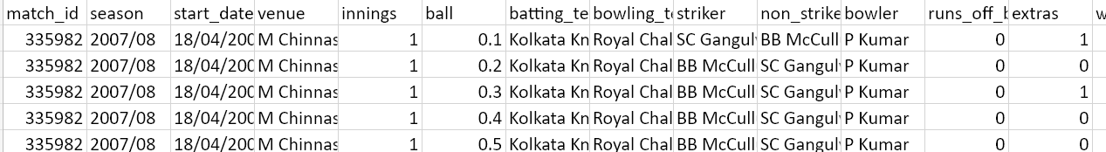

The above picture is the sample data present in the dataset. I have cross-verified the database; all the information provided is correct.

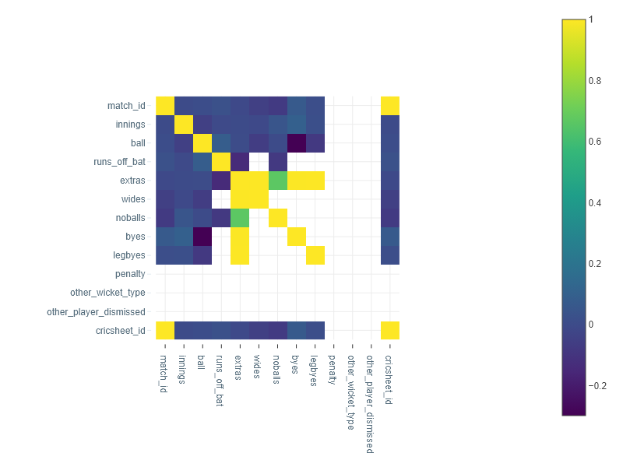

There are no significant negative correlations found in the dataset. These findings suggest that Wides, no balls, byes, and leg byes are important factors contributing to the overall extras in a cricket match. Therefore, teams and players should focus on minimizing these types of extras to improve their overall performance.

# **Potential and ethical issues:**

Based on the search results provided, some of the potential ethical issues that could arise in this project analyzing the Indian Premier League (IPL) and projecting the optimal squad for the 2025 season include:

1. **Stakeholder Engagement:**

* Ensuring fair representation and consideration of interests of all stakeholders involved, such as players, teams, league organizers, fans, and the broader cricket community.
* Maintaining transparency and accountability in the analysis and decision-making process.

1. **Conflicts of Interest:**

* Identifying and mitigating any potential conflicts of interest, such as personal or financial ties that could influence the objectivity of the analysis.
* Ensuring the independence and impartiality of the research team.

1. **Data Privacy and Security:**

* Protecting the confidentiality of player and team data used in the analysis.
* Adhering to data privacy regulations and best practices in data management.

1. **Ethical Decision-Making:**

* Establishing a clear ethical framework to guide the analysis and decision-making process.
* Developing mechanisms to address ethical dilemmas that may arise during the project.

By proactively identifying and addressing these potential ethical issues, the project can ensure that the analysis and predictions are conducted in a responsible, transparent, and ethical manner, ultimately benefiting the IPL ecosystem and its stakeholders.

# **Project schedule:**

Given the 3-month timeline and the agile methodology, here are some sample user stories and formats that could be used for the project on analyzing the Indian Premier League (IPL) and projecting the optimal squad for the 2025 season:

**User Stories**

1. Data Collection and Analysis  
As a data analyst, I want to collect and analyze historical IPL player performance data, team composition, and auction trends, so that I can identify key insights to inform the 2025 squad projections.

2. Player Performance Evaluation  
As a cricket expert, I want to evaluate the performance of current IPL players based on various metrics (runs, wickets, strike rate, etc.), so that I can identify the top performers and potential future stars.

3. Team Composition and Retention Strategies  
As a team strategist, I want to analyze the optimal team composition and player retention strategies for IPL teams, so that I can provide recommendations for the 2025 season.

4. 2025 Squad Projections  
As an IPL enthusiast, I want to receive a comprehensive report projecting the optimal squad compositions for each IPL team in the 2025 season, so that I can better understand the future landscape of the league.

5. Stakeholder Engagement and Feedback  
As a project manager, I want to regularly engage with key stakeholders (IPL teams, league organizers, fans, etc.) to gather feedback on the analysis and projections, so that I can refine the outputs and ensure they meet the needs of the broader IPL ecosystem.

**User Story Format**

Each user story should follow a standard format, such as:

**As a [user/persona],**  
**I want to [goal/objective],**  
**so that [reason/benefit].**

**Acceptance Criteria:**

For each user story, define clear acceptance criteria that will be used to validate its completion.

**Data Collection and Analysis**

* Collect and organize historical IPL player performance data, team composition, and auction trends from reliable sources.
* Analyze the data to identify key insights, trends, and patterns.
* Document the data collection and analysis methodology.

**Player Performance Evaluation**

* Develop a comprehensive set of performance metrics to evaluate IPL players.
* Assess the current performance of all IPL players based on the defined metrics.
* Identify the top-performing players and potential future stars.

**Team Composition and Retention Strategies**

* Analyze the optimal team composition (e.g., balance of Indian and overseas players, experienced vs. young talent) for IPL teams.
* Evaluate the player retention strategies used by successful IPL teams.
* Provide recommendations for the 2025 season based on the analysis.

**2025 Squad Projections**

* Develop a model to project the optimal squad compositions for each IPL team in the 2025 season.
* Provide detailed projections for each team, including player roles, strengths, and potential impact.
* Present the projections in a clear and visually appealing format.

**Stakeholder Engagement and Feedback**

* Regularly engage with key IPL stakeholders (teams, league organizers, fans) to gather feedback on the analysis and projections.
* Incorporate the feedback to refine the outputs and ensure they meet the needs of the broader IPL ecosystem.
* Document the stakeholder engagement process and how the feedback was incorporated.

By using this agile user story format and defining clear acceptance criteria, the project team can effectively plan, execute, and deliver the comprehensive analysis of the IPL and the optimal squad projections for the 2025 season.

# **References:**

1. Khandelwal, M., Prakash, J., Pradhan, T. (2016). An Analysis of Best Player Selection Key Performance Indicator: The Case of Indian Premier League (IPL). In: Berretti, S., Thampi, S., Srivastava, P. (eds) Intelligent Systems Technologies and Applications. Advances in Intelligent Systems and Computing, vol 384. Springer, Cham. <https://doi.org/10.1007/978-3-319-23036-8_16>
2. Wedage, Lasantha & Jayasekara, Leslie. (2020). Analysis of the Performance of Players of Cricket World Cup 2019 by Principal Component Analysis.
3. Fogt, Jennifer & Fogt, Nick. (2023). Studies of Vision in Cricket—A Narrative Review. Vision. 7. 57. 10.3390/vision7030057.
4. Robel, Md & Khan, Dr. Md. Ashikur & Ahammad, Ishtiaq & Alam, Md. Mahbubul & Hasan, Mohammad Kamrul. (2023). Cricket Players Selection for National Team and Franchise League using Machine Learning Algorithms. Cloud Computing and Data Science. 5. 108-139. 10.37256/ccds.5120243741.
5. Gweshe, Tsungai & Durbach, Ian. (2013). An analysis of the efficiency of player performance at the 2011 Cricket World Cup. ORiON. 29. 137-153. 10.5784/29-2-123.
6. Shah, Sricharan & Hazarika, Partha & Hazarika, Jiten. (2019). A Study on Performance of Cricket Players using Factor Analysis Approach. International Journal of Advanced Research. 8. 656 - 660.
7. Chandrakar, Pranjal. (2022). Measuring the values of cricket players. Australian & New Zealand Journal of Statistics. 63. 10.1111/anzs.12353.
8. Hemanta Saikia, Dibyojyoti Bhattacharjee & H. Hermanus Lemmer (2012) Predicting the Performance of Bowlers in IPL: An Application of Artificial Neural Network, International Journal of Performance Analysis in Sport, 12:1, 75-89, DOI: 10.1080/24748668.2012.11868584
9. C. Petersen, D.B. Pyne, M.J. Portus & B. Dawson (2008) Analysis of Twenty/20 Cricket performance during the 2008 Indian Premier League, International Journal of Performance Analysis in Sport, 8:3, 63-69, DOI: [10.1080/24748668.2008.11868448](https://doi.org/10.1080/24748668.2008.11868448)
10. Mansurali, A., Harish, V., Hussain, S., Choudhury, T. (2023). Profiling the IPL Players—Sports Analytics Through Clustering Algorithms. In: Ramdane-Cherif, A., Singh, T.P., Tomar, R., Choudhury, T., Um, JS. (eds) Machine Intelligence and Data Science Applications. MIDAS 2022. Algorithms for Intelligent Systems. Springer, Singapore. <https://doi.org/10.1007/978-981-99-1620-7_5>
11. S. G, A. Swaminathan, J. B. J, S. R and L. Nelson, "IPL Data Analysis and Visualization for Team Selection and Profit Strategy," 2023 7th International Conference on Computing Methodologies and Communication (ICCMC), Erode, India, 2023, pp. 592-598, doi: 10.1109/ICCMC56507.2023.10083736.